Read and answer these questions:  - Who are they?  - Where are they?  - What do they look like?  - How much attention do they pay to their looks? Why?  - What are they going to do next?  You want to know this information about a new roommate.  Make up some questions to ask about  - the most memorable vacation  - description of something they would never wear  - appropriate behavior in public places | 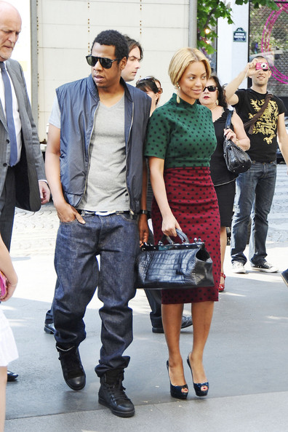 | Active vocabulary  - V-neck  - polka-dot  - to care about appearance  - to wear make-up  - baggy  - sneakers  - to fit perfectly  - to be in the charts  - inappropriate  - to stare at  - acceptable  - to plan on  - similar  - festival  - compliment
Read and answer these questions:  - Who are they?  - Where are they?  - What’s the party supposed to be like?  - What are they going to do next?  You want to know this information about a new roommate.  Make up some questions to ask about  - the most reasonable punishment for  speeding  - superstitions  - his or her personal style | 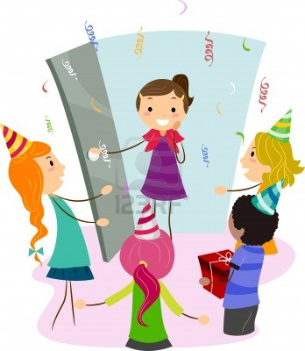 | Active vocabulary  - to appear out of nowhere  - to have company  - close  - unexpectedly  - to turn (age)  - to be filmed on camera  - to fit perfectly  - to tell a white lie  - to be the center of attention  - surprise party  - upcoming event  - extroverted  - to cancel plans  - to celebrate  - to get the feeling that
Read and answer these questions:  - Who are they?  - Where are they?  - What’s going on? Why? Suggest different ideas.  You want to know this information about a new roommate.  Make up some questions to ask about  - types of services that he or she needs quite regularly.  - important social skills  - managing money | 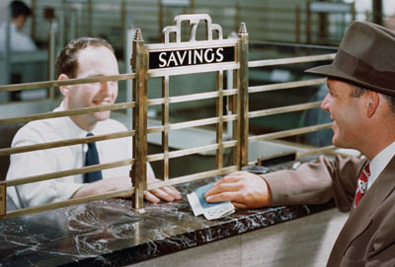 | Active vocabulary  - saver  - to open a savings account  - apparently  - to fill out an application  - to put money away for a rainy day  - to manage emotions  - disciplined  - intelligent  - to set goals  - to keep track of  - reliable  - to take a look at  - to build a new house  - to push ahead  - confidence
Read and answer these questions:  - Who is she?  - Where is she?  - What has she just done?  - What happened earlier?  - What’s going to happen to her in the future?  You want to know this information about a new roommate.  Make up some questions to ask about  - choosing a university.  - planning vacation  - technologies |  | Active vocabulary  - to get an early start  - to be in the headlines  - to have the confidence to  - to have a difficult childhood  - to get a standing ovation  - in the right place at the right time  - instead of  - the media  - to end up as  - to have connections  - to write a best-selling book  - to enter a contest  - to go to an audition  - to end up with …  - to win a talent show

