Электрическое сопротивление.Оределение баланса мощности. Данные параметрыв таблице

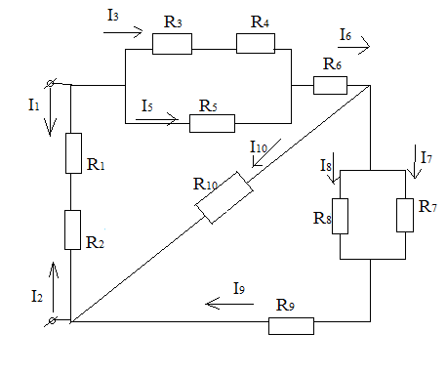

|  |  |  |  |  |  |  |  |  |  |  |  |  |
| --- | --- | --- | --- | --- | --- | --- | --- | --- | --- | --- | --- | --- |
| № | R1 | R2 | R3 | R4 | R5 | R6 | R7 | R8 | R9 | R10 | I | U |
| 3. | 3 | 2 | 6 | 7 | 5 | 10 | 4 | 8 | 10 | 9 | 4 |  |