Read and answer these questions:  - What guesses can you make about the picture? Ask your partner questions about the picture.  - Have you ever failed your exams before? Can you remember when it was and why?  - How good are you at managing your life? Are you good at organizing your study? Do you like to study?  - What are your priorities in life? What things matter to you?  - What would you do if you had your life to live over? What would you change?  - What’s something you’ve always wanted to learn how to do?  - What are you planning to use English for?  Read the situation below, and explain it to your partner. Then role-play the conversation. Use the Conversation Strategy: Ask politely for a favor. Continue the conversation as long as you can.  You are a student and your partner is the teacher. You haven’t finished writing a report, and you want to ask for an extension on your paper. |  | Active vocabulary  - might want to  - to be able to  - to do volunteer work  - to make an effort to do something  - deadline  - clutter  - to get a (full) scholarship  - major in  - definitely  - afterwards  - to make sense  - to make a living  - to ignore a problem  - to make up your mind  - to do something about a problem
Read and answer these questions:  - What guesses can you make about the picture? Ask your partner questions about the picture.  - Have you ever been to any other countries? What’s the most interesting place you’ve ever been to?  - What’s the worst vacation you’ve had? Did you feel really disappointed? What happened?  - What’s an activity that you’ve never tried but would like to try?  - Have you ever seen an active volcano? Is it dangerous? Why?  - Can you remember how old your native city is?  - How many times have you gone out this month? If you had one month of free time, what would you do?  Make a statement about the topic “an activity you’ve been enjoying a lot”, and respond to your partner’s statement. Use the Conversation Strategy: When responding, use That must be plus an adjective. Then continue the conversation | 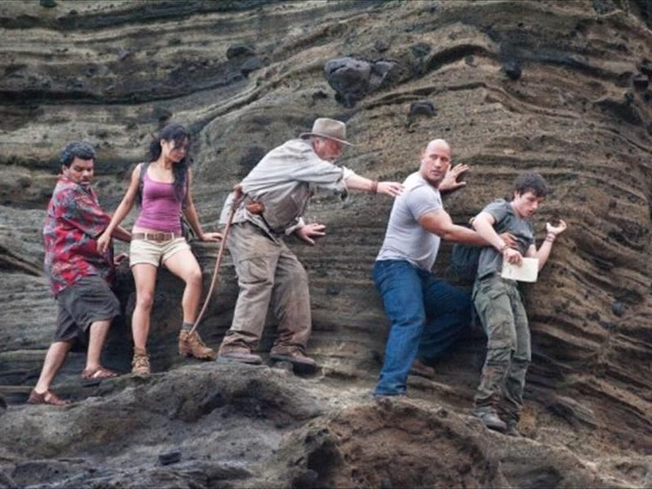 | Active vocabulary  - to fall and hurt yourself  - to lose something important  - to climb  - to cause/be caused (by)  - natural wonder  - injury  - to be scared  - amazingly  - mountain range  - aftershock  - earthquake  - ancient city  - erupt  - badly (damaged)  - valley
Read and answer these questions:  - What guesses can you make about the picture? Ask your partner questions about the picture  - Do you like people-watching? Which people would you like to meet? Why?  - Who is someone you really admire? Why? What is he/she like?  - Do you know someone who is always singing or whistling? Is it annoying? When is the last time you got annoyed with someone?  - If you had to give up one habit, what would it be?  - Who’s your closest friend? How did you meet?  - What is the most exciting thing you’ve ever done with your friends?  Take turns starting conversations. Talk to your partner about the topic below. Respond to your partner. Use the Conversation Strategy: Use expressions such as I guess/ I think, a (little) bit, maybe or kind of/ sort of to soften your comments.  Your friend borrows things and keeps them a long time. Sometimes he or she doesn’t remember that he or she borrowed them. |  | Active vocabulary  - to balance work and play  - to apologize to someone  - to trust someone  - to slow down  - circle of friends  - to get impatient  - jealous  - to be pleased (about)  - considerate  - generous  - laid-back  - incredibly  - on time  - selfish  - reckless
Read and answer these questions:  - What guesses can you make about the picture? Ask your partner questions about the picture.  - How would you react if a friend started dating someone you used to go out with? Would you talk to your friend about your feelings?  - Are people getting married later these days? What’s a good age to settle down? Why?  - Do you think families should spend more time together? Is it bad for children when both parents work?  - Have you been spending much time with your family lately?  - Do you have any gripes about your family? Which of your parents’ demands do you think are not reasonable?  Ask this question. Answer your partner’s question. Use the Conversation Strategy: When answering, give your opinion using an expression such as I (don’t) think, It seems like, It seems to me (that), or If you ask me, …. Then continue the conversation.  1. Is it a good idea for kids to work?  2. Should kids have a pet when they’ve growing up? |  | Active vocabulary  - to break up (with someone)  - to get back in touch (with someone)  - to get along (with someone)  - to hang out with  - long-distance relationship  - to lose touch  - used to  - only child  - at the age of  - nowadays  - to let someone do something  - to have someone do something  - to work out  - to grow up  - to get divorced

